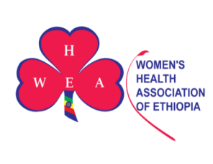

Annual Twinning Report
Assosa
01st January – 31st December 2023
Twinning Partners- Trondhjem SF & Orkdal SF

ASSOSA LOCAL UNIT
Assosa had two local units: one that is older (the one engaged in dairy farm (with 22 members) and graduated at the end of 2023) and the recently established one (with 20 local unit members) which is engaged in poultry farming.

COMMUNITY CENTER RENTAL
Twelve (12) monthly health education sessions had taken place at rented the community center in 2023. The women’s blood pressure and blood has been measured and recorded on individual charts.

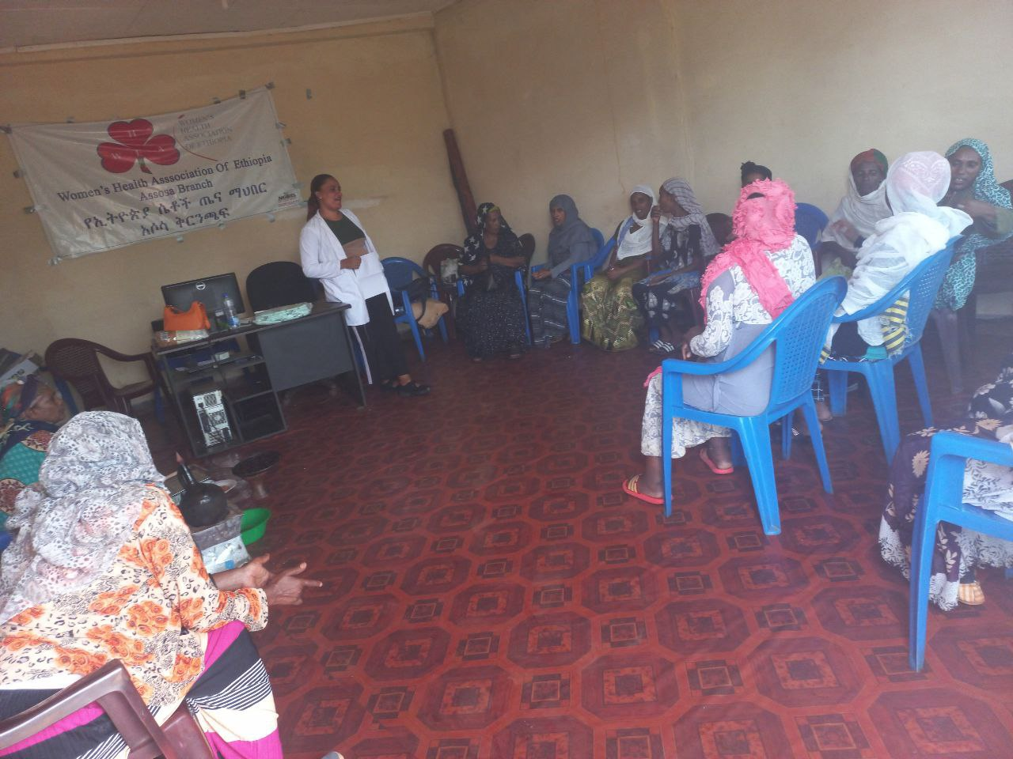
Monthly health education

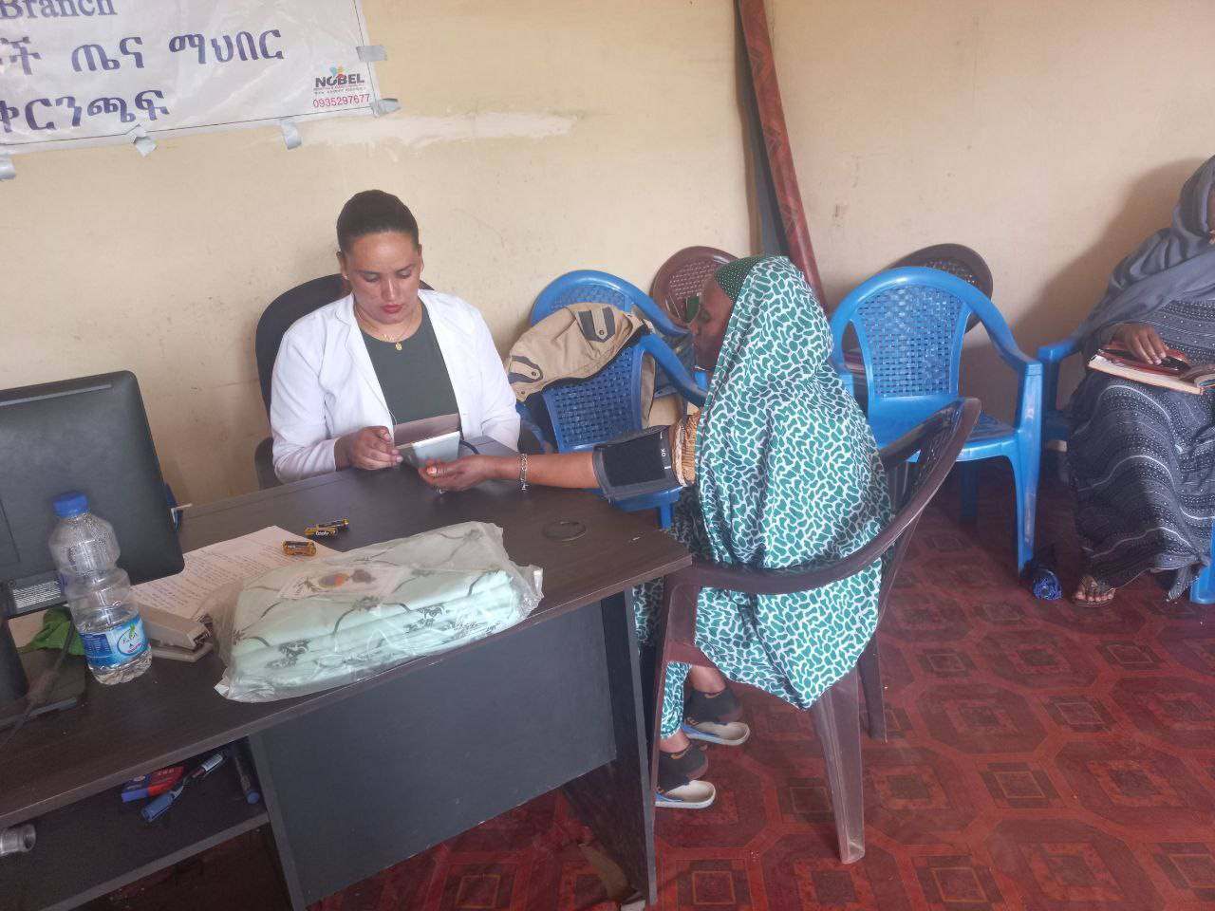
Vital signs monitor

HEALTH INSURANCE
WHAE has paid government Community Based Health Insurance for the 20 local unit members in 2023. The government Community Based Health Insurance (CBHI) is a type of health insurance program that provides financial protection against the cost of illness and improving access to health care services for communities engaged in the informal sector.

CLEANING CAMPAIGNS
Four (quarterly) cleaning campaigns have been organized in 2023 by the two local units. The women clean their neighborhoods trying to inspire community members to participate. Cleaning supplies, including brooms, smocks, gloves, shoes, rakes, and shovels, were bought for the women. Local unit women also received body and laundry soaps.

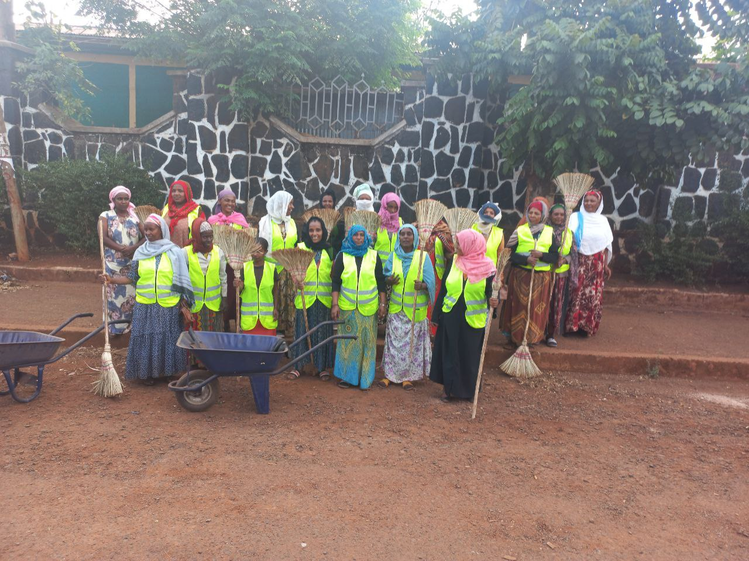
Cleaning Campaign
PROVISION OF SANITARY MATERIALS
The objective of providing personal hygiene products is to empower our local unit women by enabling them to take care of their personal hygiene, which will boost their confidence and enable them to pursue their goals and engage in their communities. It also aims to prevent the spread of diseases and improve general health.
WHAE provided sanitary products to members of the local unit during the program implementation period. 504 bars of body and cloth soaps were given to 42 local unit members throughout the course of the year.
NUTRITION DEMONSTRATION
The goal of nutrition education and demonstration is to inform local unit and community women (GOT) about the advantages of a healthy diet, encourage them to consume more fruits and vegetables (within their means), and help them avoid overcooking vegetables.

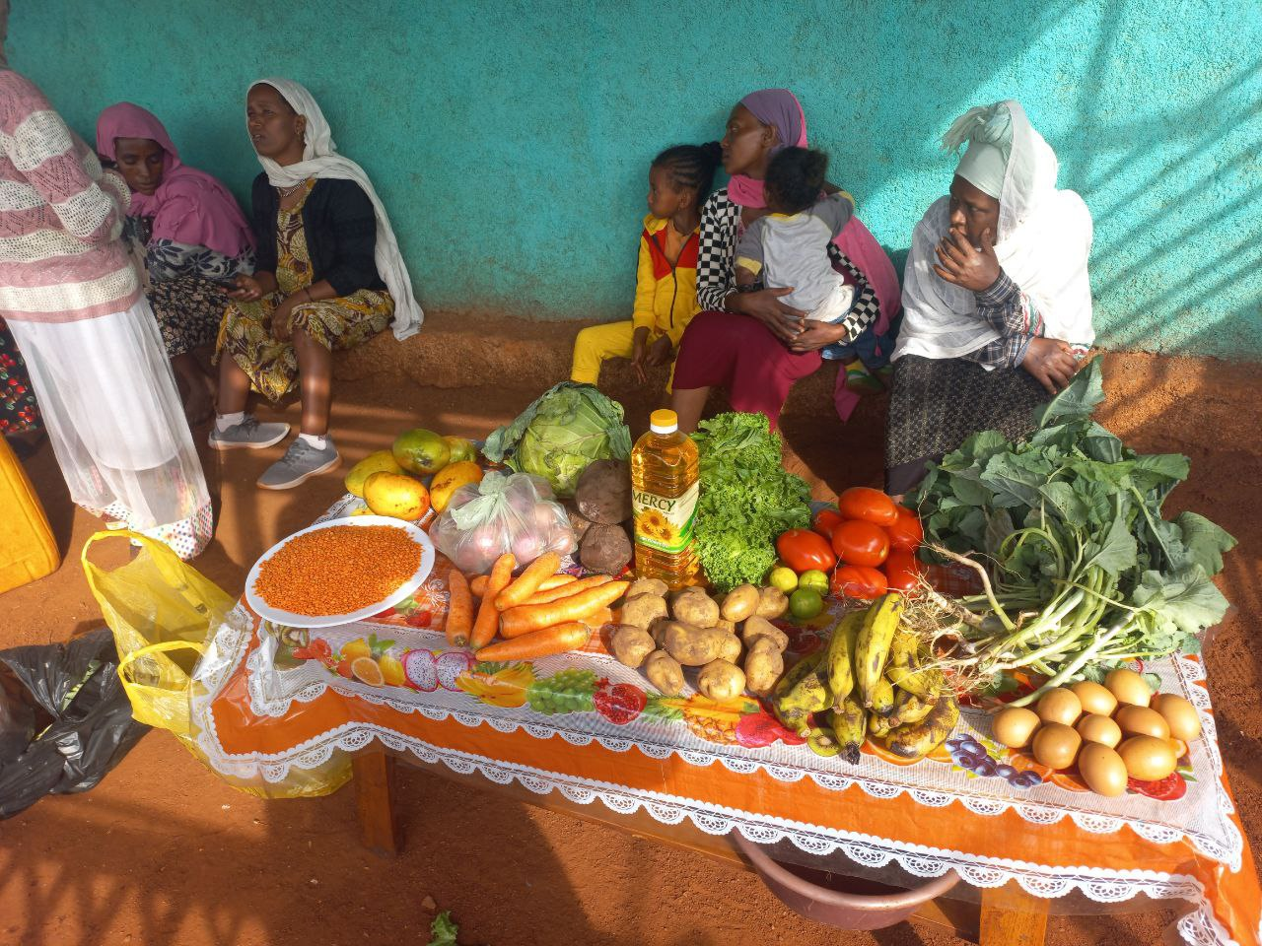
Nutrition demonstration
URBAN GARDENING
Because of the high cost of living and as part of the nutrition campaign program, and to improve the nutrition intake and nutrition security among local unit and GOT women, WHAE provided seeds to all local unit women in June (planting season) to plant in their backyards or in pots. The women received seeds such as Swiss chard, cabbage, black cabbage, carrots and tomatoes.

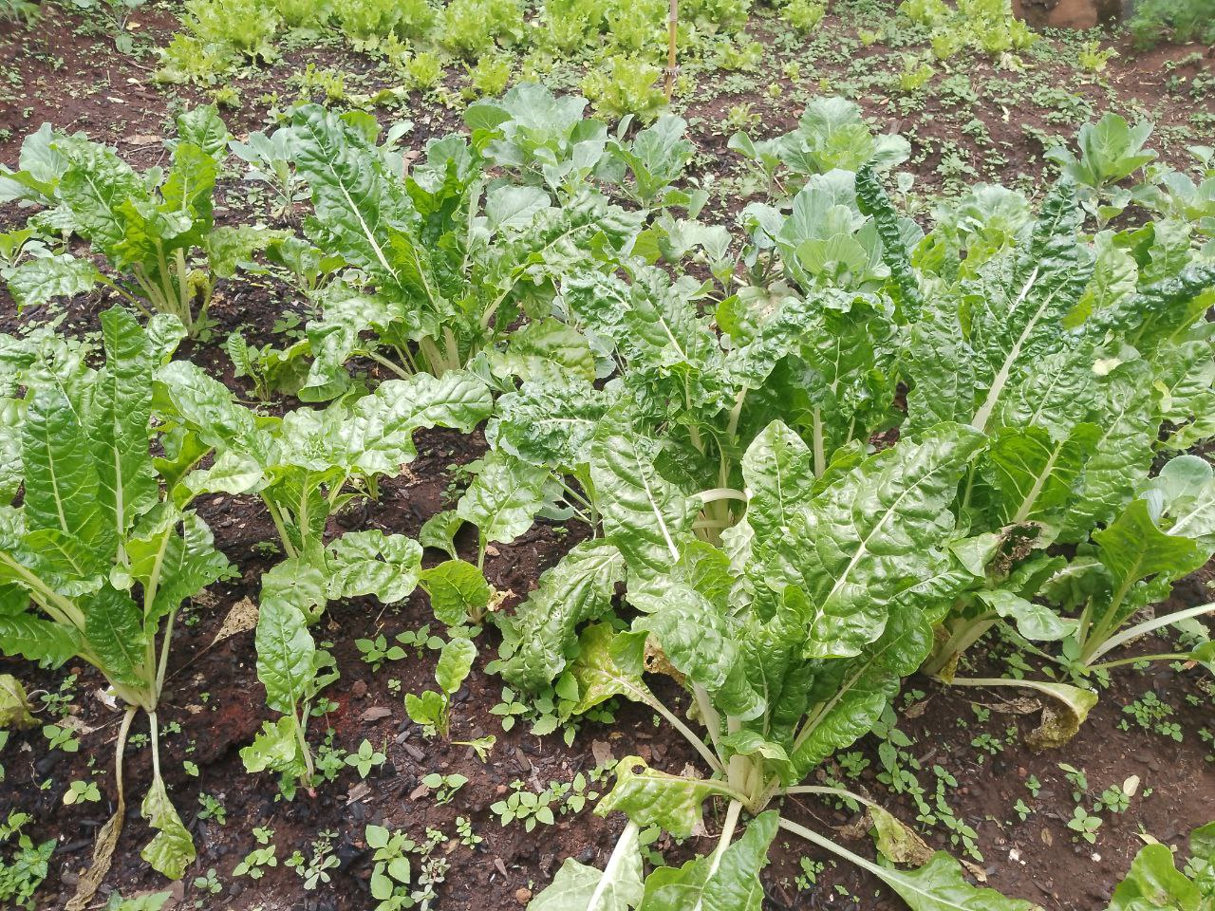
Urban garden
DAIRY FARM
Dairy farm local unit graduated in 2023 after almost five years with WHAE. WHAE monitors their business from a distance and they are so far doing well. A new local unit has replaced the outgoing local unit and the group is engaged in poultry farming.
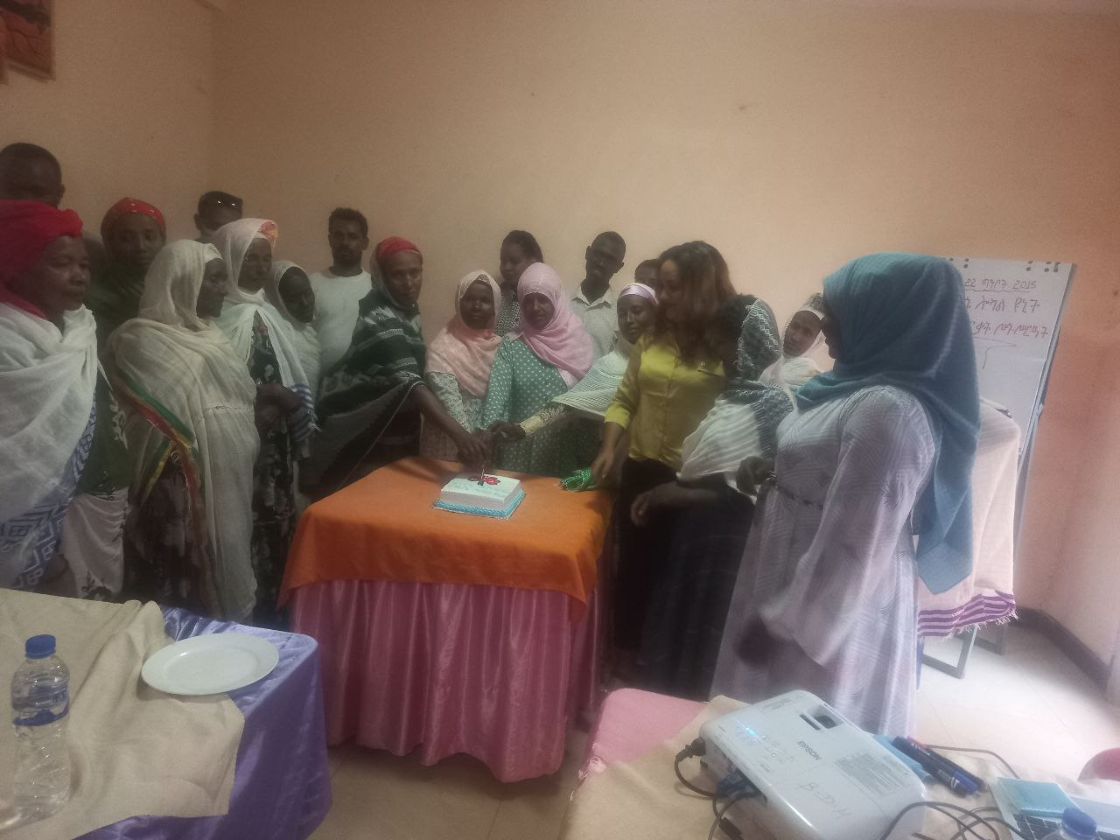
Dairy farm local unit graduation ceremony
Steering Committee Meetings
The Steering Committee, which was made up of representatives from the local government's finance, health, and women's affairs bureaus as well as members of the community and local unit women, met 4 times in 2023 and refreshments and per diems were covered by WHAE during the reporting year. Finding a production shed for the new local unit was one of the subjects covered, along with keeping track of program activities.

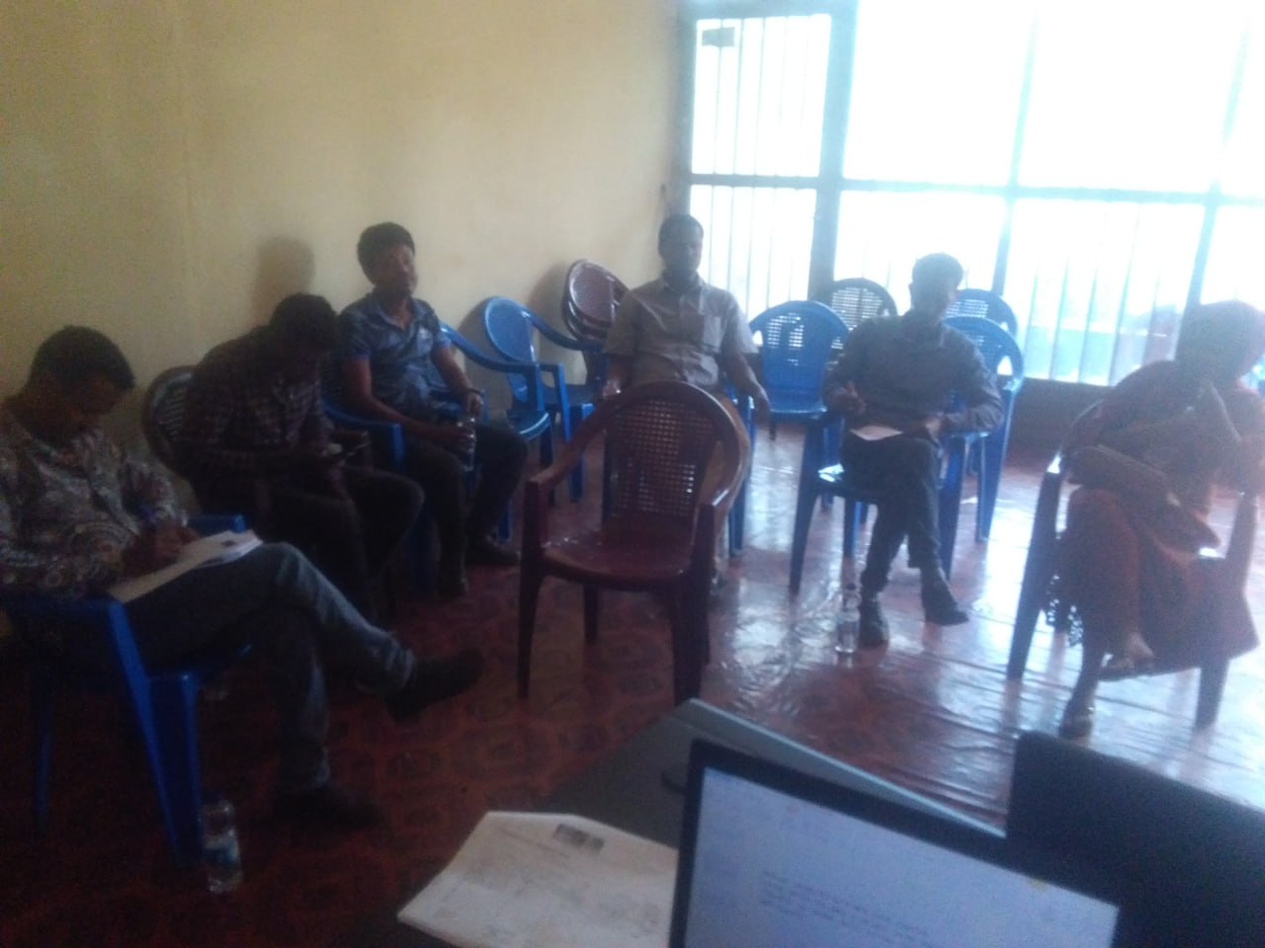
Steering committee meeting

Plan for 2024
- Continue the Health Insurance program
- New Local unit recruitment
- Graduate the local unit that engage in poultry and individual business
- Purchase of lottery material during monthly local unit and Got health meetings

